System Architecture (New)

CxSAST includes the following components:
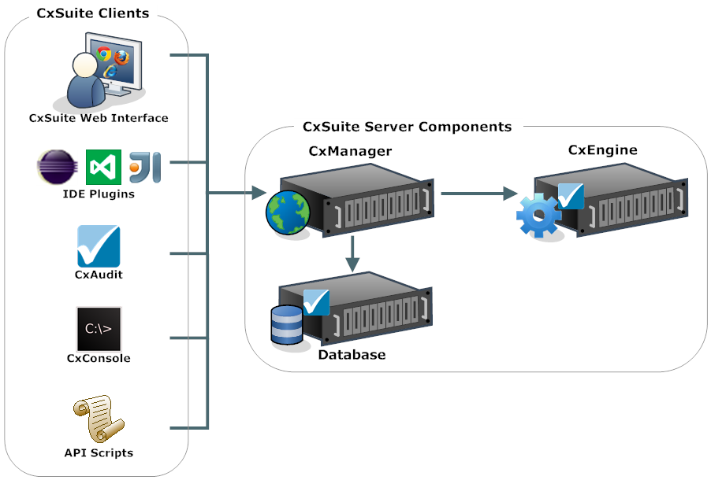
Server components:
  - CxEngine: Performs code scans.
  - Database: Stores scan results and system settings. Can be an existing MS SQL Server (recommended for production), or SQL 2012 Express - can be installed with CxSAST (appropriate for POCs).
  - CxManager: Manages system and performs all system functions. Integrates system components. Uses the IIS web server (recommended for poc/production), or UltiDev can be installed with CxSAST (appropriate for POCs).
Clients: User interfaces, including:
  - CxSAST Web Interface
  - IDE Plugins
  - CxAudit
  - CxConsole: CxSAST CLI
  - CxSAST API
- found
CxSAST supports a Centralized architecture, where all server components are installed on the same host, or a Distributed architecture, where any or all of the server components are installed on dedicated hosts.
CxSAST also supports High Availability (HA) architecture, where all server components are installed for optimal operational performance, even at times of high loads. The main objective of implementing High Availability architecture is to make sure CxSAST is configured to handle different loads with minimal or no downtime.
Since Checkmarx recommends one scan at a time per CxEngine server, in the event of concurrent scans multiple CxEngine servers should be used. High scan loads are balanced among CxEngine servers; each CxEngine server can handle about 130K lines of code per hour.
Communication between clients and the CxManager, and communication between the CxManager and the CxEngine, are via HTTP. HTTPS can also be configured.

See also:
- Centralized Architecture
- Distributed Architecture
- High Availability Architecture

